The Pocklington Friends of
St Leonard’s Hospice

The 2022 Charity Calendar Photographic Competition
Spring 2021

Wildlife and Landscapes of Pocklington
& Surrounding Villages

Entry Form
(Important: a separate copy of this Entry Form needs to accompany each image submitted)

Name:
Home Address:

Telephone:

Email Address:
I will be entering a total of 1/2/3 (delete as appropriate) images.
Please find attached image 1/2/3 of 1/2/3 (delete as appropriate).
I confirm that:

- I am over 16 years of age.
- I am the creator and copyright holder of the submitted images, and that the images have not been (and will not shortly be) published for money elsewhere.
- The Friends of St Leonard’s Hospice will have authorised use of each successful image for the purpose of producing and publicising the calendar.

Signed:
Date:
Entries must be submitted by email to: richardknill@hotmail.com
Entries must be received by Wednesday 30 June 2021

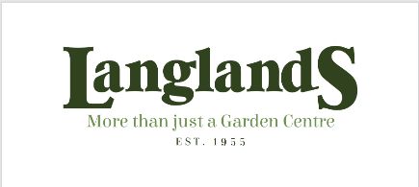
Our Main Sponsors

